**US04 – Q-scores**

## **Short description**

**In order to** allow easier evaluation at the end of the year

**As a** PM/portfolio manager or someone from ASF leadership

**I want to** add a score to evaluate performance every quarter

## **Detailed description**

Next to tracking whether or not a monthly conversation has taken place, the PM or portfolio manager (or member of ASF leadership) should have the possibility to add a quarterly score on the overview. By clicking a quarter button, he should have the possibility to select a score (no free text) ranging from 1 to 5

## **Mockups**

No specific mockup for this story, but the score is also visible on the following mockup from US03

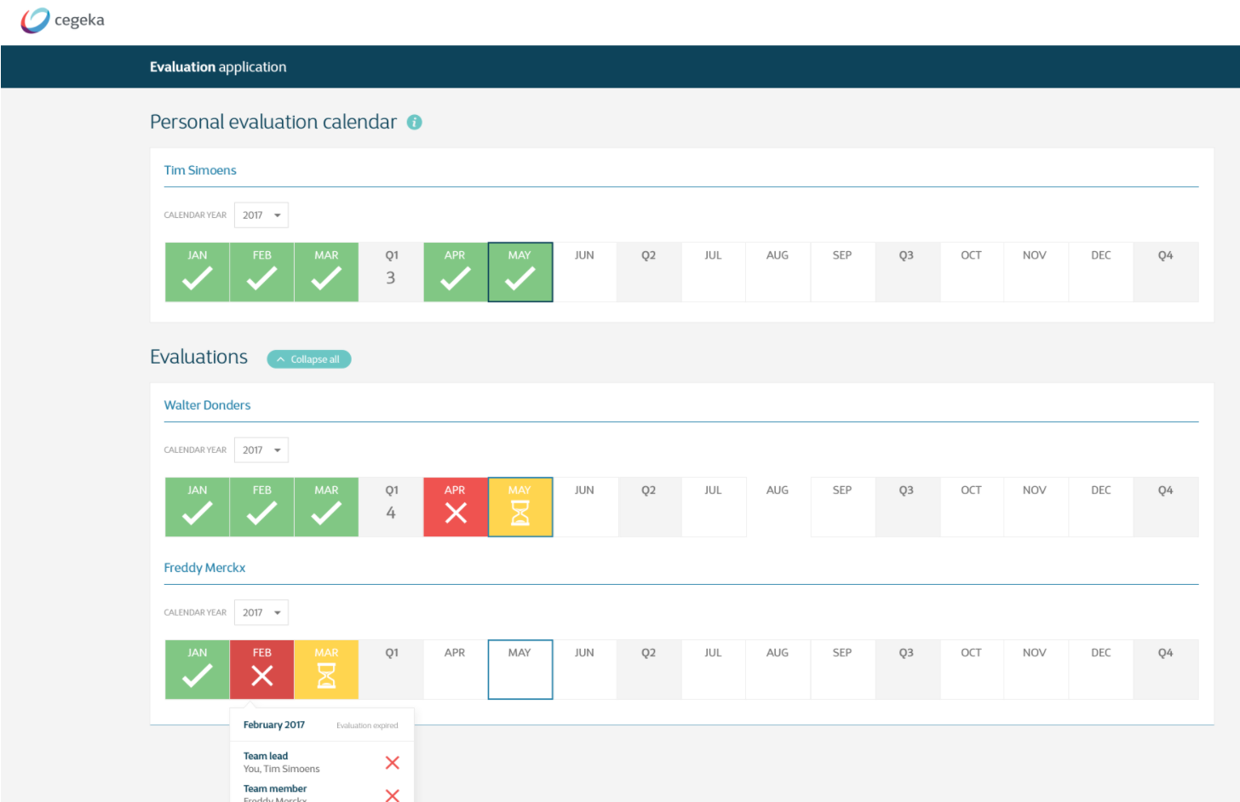

## **Technical description**

## **Acceptance criteria**

|  |  |  |
| --- | --- | --- |
| **Given** | **When** | **Then** |
| I am logged into the tool as a PM/portfolio manager | I click on a quarterly button | I am able to set a score (1-5) from a drop-down menu. |
| I have selected a score for someone, and the 15 days since the Q ended have not yet passed | I want change it | I will be able to change the score without an issue (the same way as it was set earlier, so selected from a drop-down menu) |
| I have selected a score for someone, and the 15 days since the Q ended have passed | I want change it | The button is no longer clickable, the score cannot be changed anymore |
| I have given a rating to someone’s quarterly performance | that person opens the tool | the score should be visible to him/her |
|  |  |  |
|  |  |  |